PHASE II: SMART HOUSE RENTING MANAGEMENT SYSTEM.

BUSINESS PROCESS MODOLING.

Project Title: Smart House Renting Management System
Course: PL/SQL Capstone Project (INSY 8311)
Lecturer: Eric Maniraguha
Phase 2 Focus: Understanding and modeling how the system works before building the database

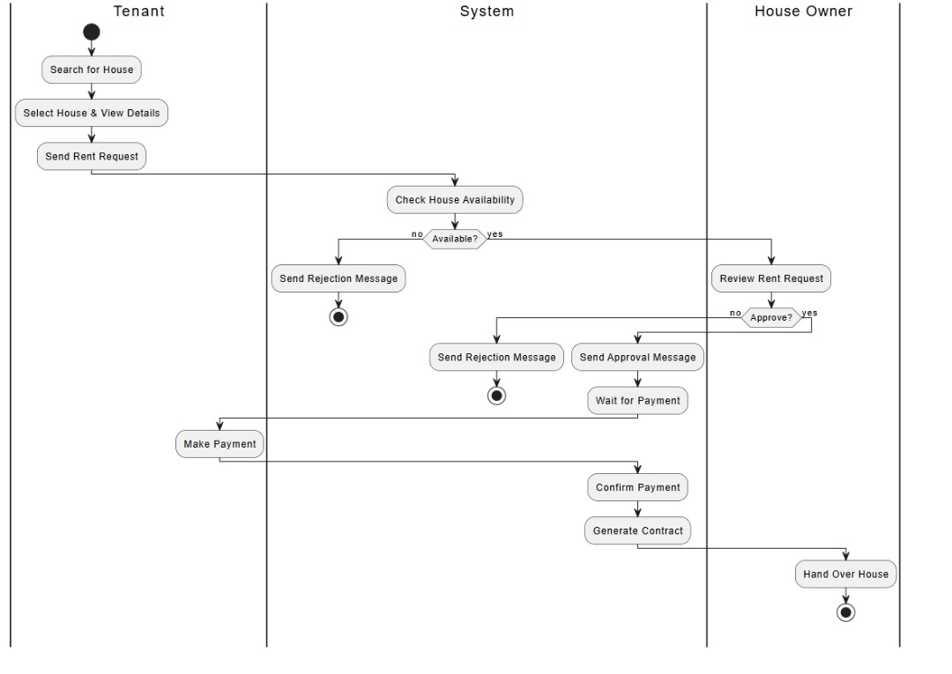

Introduction
In this phase, we were asked to model a real-world business process that shows how information moves between people and systems. This is part of Management Information Systems (MIS).
The main goal is to visualize how our house rental management system works --- step by step --- and to understand how different users interact with it. We used a process diagram with swim-lanes to clearly show which part is done by the Tenant, Property Manager, PL/SQL System, or Vendor.
This helps us:
- Know what the system should do.
- Plan how the database will support each activity.
- Make sure everyone's role is clear.
Explaining the Diagram Step by Step

1.Tenant (Top Lane)
This is the person who wants to rent a property.
i. Start: The tenant begins the process.
ii. Search for Properties: The tenant looks for available rental properties through online listings or agent.
iii. Submit Rental Application: They choose a property and submit their personal and financial information.
iv. Sign Digital Lease: If approved, the tenant signs the lease agreement electronically.
v. Pay Security Deposit & First Month Rent: The tenant makes initial payments to secure the property.
vi. Move into Property: The tenant receives keys and moves in.
vii. Monthly Rent Payments: Throughout the lease, the tenant pays rent monthly.
viii. Report Maintenance Issues: The tenant submits repair requests as needed.
ix. Renew or Move-out Decision: When lease ends, the tenant decides to renew or move out.

2. PL/SQL Rental System
This is the automated system that processes information and handles business logic.
i. Perform Auto Background Check: The system automatically screens tenant applications.
ii. Generate Digital Lease Agreement: Creates customized lease contracts.
iii. Update Property Status: Changes property status from "Available" to "Rented".
iv. Schedule Monthly Rent Invoices: Automatically generates rent due notices.
v. Auto-Prioritize Maintenance Requests: Classifies repair urgency automatically.
vi. Send Renewal Notices: Proactively notifies tenants 60 days before lease end.

3. Property Manager
The manager oversees operations and ensures everything runs smoothly.
i. Review Application Details: Manually reviews tenant applications after system screening.
ii. Assign Maintenance Vendors: Coordinates with repair service providers.
iii. Schedule Final Inspection: Conducts move-out property assessment.
iv. Process Security Deposit: Handles deposit refunds or deductions.
This ensures there are no mistakes in tenant selection and property maintenance.

4. Vendor
Service providers who handle property maintenance and repairs.
Perform Maintenance: Vendors complete repair work assigned by the property manager.
Update Completion Status: Vendors report when maintenance is finished.

Why This Process is Useful for MIS
This process supports Management Information Systems (MIS) in several ways:
i. Improves decision-making: Property managers get real-time data on occupancy rates, payment status, and maintenance needs.
ii. Automates routine tasks: The system handles background checks, invoice generation, and renewal reminders automatically.
iii. Tracks financial performance: Automated payment tracking and reporting help monitor rental income and expenses.
iv. Clear responsibility allocation: Each participant (tenant, manager, system, vendor) has defined roles and responsibilities.
v. Enhances tenant experience: Quick maintenance response and automated communications improve satisfaction.

Conclusion
To sum it up, this diagram clearly shows how the house rental management process works --- from when a tenant starts searching for a property to ongoing management and eventual move-out or renewal. By using swim lanes, we made it easy to understand who does what.
This phase is very important because:
- It helps us design the database tables and relationships properly.
- It shows us how to implement business logic in PL/SQL procedures and functions.
- It improves rental operations by making everything efficient and automated.
- It demonstrates how technology can transform traditional property management.

Understanding this process will guide us as we start creating our database using PL/SQL in the coming phases, ensuring we build a system that meets real-world rental management needs while leveraging database automation capabilities.

